***Choose*** ***respect!***

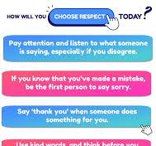

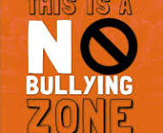You wouldn’t like it if someone was mean to you!

ANTIBULING WEEK STANDS

Why is it mean to be to bully someone?

* Because it is really sad to be bullied
* It is hurtful
* It can make them sad

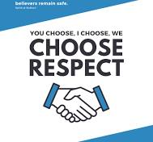Nobody will have to suffer being bullied ever again. Be kind to everyone not just your friends and online to others aswell!

