**Year 1**

**Choose respect**

1. Helping others if they have hurt themselves
2. 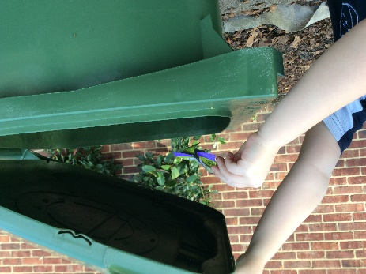Being kind to others
3. Sharing toys and games
4. Tidying up when we have finished playing
5. Don’t hurt other people-not hitting or kicking
6. 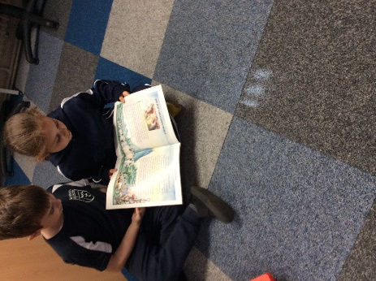Don’t put rubbish on the ground-use a bin
7. Listen to the teachers in the classroom
8. Say please and thankyou
9. Help carry books or toys
10. Open the door for an adult

