Choose

Respect

**Some things that you can do to show respect are …………………**

.Help someone if they fall over

.Be kind online and offline

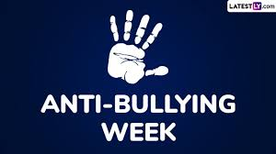

ELLIS