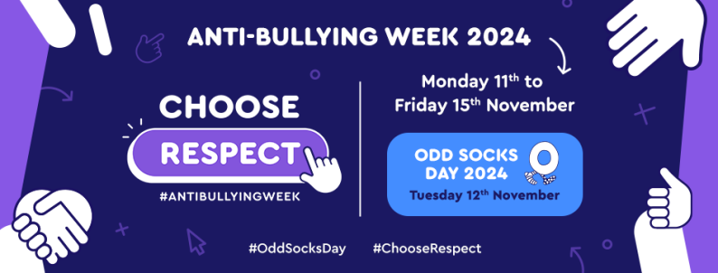

**Year 1**

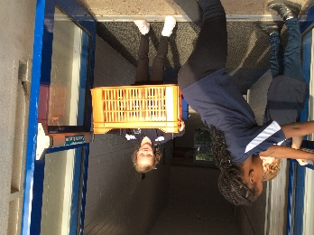**Choose respect**

* 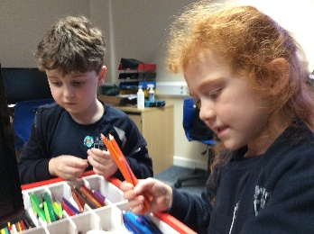**Don’t hurt other people**
* **Share the things you have-equipment**
* **Be kind to other people- don’t hit them**
* **Be kind to your friends by saying please and thankyou**
* 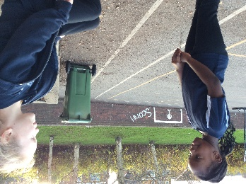**If your friend falls over take them to a teacher**
* **Don’t break equipment**
* **Put rubbish in the bins-you might slip**
* **Use kind words-‘I like your belt’**
* **Open the door for adults**
* **Ask others if you can help them**