



**SEND Information Report 2023-2024**

Our SEND Information Report tells the story of our everyday practice and provision for our SEND children.

It aims to answer a wide range of questions, listed below. However, if you have any further questions then please get in touch with the school office and we will be pleased to help you.

1. How does the school know if children need extra help and what should I do if I think my child may have special educational needs (SEN)?
2. How will school staff support my child?
3. How will the curriculum be matched to my child’s needs?
4. How will both you and I know how my child is doing and how will you help me to support my child’s learning?
5. What specialist services are available at or accessed by the school?
6. What training are the staff supporting children with SEN had or having?
7. What support is available for improving the social and emotional development of children with SEN?
8. How will my child be included in activities outside the classroom, including school trips?
9. How accessible is St Wilfrid’s?
10. How will the school prepare and support my child to join the school and later transfer to a new school for the next stage of education and life?
11. How are the school’s resources allocated and matched to children’s special educational needs?
12. How is the decision made about what type and how much support my child will receive?
13. What are the arrangements for evaluating the effectiveness of the provision made for children and young people with SEN?
14. How do we consult pupils with SEN and involve them in their education?
15. What are the arrangements relating to the treatment of complaints from parents of children with SEN concerning the provision made at school?
16. How are parents involved in the school? How can I be involved?
17. Who can I contact for further information?



1. **How does the school know if children need extra help and what should I do if I think my child may have special educational needs or disability (SEN)?**

Talk through concerns.

Teacher has a concern.

Concern is raised by parent/carer.

Concerns recorded.

Concern is raised by a member of teaching support.

Concern is raised from previous setting.

Regular review and communication between all involved parties.

Include child in an in-school intervention group as appropriate to their needs.

Refer to appropriate agency or support service.

Use strategies and resources suggested by SENCo.

Use Graduated Approach to form a plan of action and record in an IDP and adjust SEN register if appropriate.

Teacher or SENCo to communicate with parents and carers.

Ask the parents/carers their views on ways forward.

Gather the opinion of the child.

SENCo

Discuss and record concerns.

Look at assessment data and previous records.

Talk to previous teacher and teaching assistant for further context.

Talk through concerns.

If your child is due to start school in Reception in the following school year, you should make an appointment, through the school office to discuss his or her needs with our SENCo.

When your child is new to the school then progress will be discussed with your child’s nursery or previous school to enable suitable support to be implemented. The teachers at St Wilfrid’s know the children in their class well and if there are any concerns about your child’s progress or attainment or if it is felt your child needs extra support, this is identified early and acted upon.

Regular progress meeting are held to discuss your child’s progress with the appropriate staff in school. The class teacher will talk to you if they have any concerns about your child. Parents and carers can talk to the class teacher or SENCo at a mutually convenient time if they feel that their child may have SEN.

1. **How will school staff support my child?**

Every child will be supported according to their need. The teacher, supported by the SENCo, will plan and explain to you a programme of support if one is needed. The class teacher will review this plan half termly and your views will be sought. At St Wilfrid’s we call these plans, Individual Development Plans (IDP’s).

1. **How will the curriculum be matched to my child’s needs?**

Class teachers adapt their teaching and the subsequent learning to meet the needs of all children in their class. This will ensure that your child’s needs are being met. For some children this may mean that they have adapted work planned for them to enable their unique needs to be met in the classroom.

1. **How will both you and I know how my child is doing and how will you help me to support my child’s learning?**

Class teachers and the SENCo are always willing to talk to parents though it is advisable to make an appointment through the school office as staff often have meetings to attend before and after school.

Parents are invited to events in school that help them know how to support their child in their learning. The IDPs also contain information on how to support your child at home.

Our school website has lots of information about sources of support, information about the main special needs that we see and information about the current learning in class.

1. **What specialist services are available at or accessed by the school?**

Our SENCo can signpost you to the most appropriate agency to support your child. We can refer children to the following services as appropriate (subject to waiting lists) and current referral guidelines.

Some of the services below are offered on a prioritised basis, depending on the needs of your child and the other children in the school.

1. **What training have the staff supporting children with SEND had or having?**

Our staff continually participate in Continuing Professional Development opportunities that equip us to support children with SEN. We continually take guidance from outside agencies and adapt our training schedule when the need arises.

Examples of this include: Epipen training, Speech and Language training courses, Autism Aware training, Communication Friendly Classroom, Narrative Therapy, Social Stories, Team Teach, Lego Therapy, Makaton training, Sports Leaders and Sensory Support training.

We are proud to have been awarded the Autism Aware Award in 2023.

1. **What support is available for improving the social and emotional development of children with SEN?**

At St. Wilfrid’s we have a Play Therapist and a Learning Mentor who are able to support children who have emotional barriers to learning.

Less structured times can be particularly challenging for children with social and emotional difficulties. The arrangements include:

Our Buddy system which links classes across the school together. Some of our children prefer to stay inside at playtimes as they need time away from other people and we can also accommodate this. We have a comprehensive PSCHE curriculum that supports all of our children to be healthy in both their physical and mental health. Our curriculum also supports children to develop healthy habits when it comes to use of the internet, social media and other technology in an age appropriate manner.

Extra pastoral support arrangements can be made for listening to the views of children and young people with SEN. We know that these children may need additional support to express themselves. Listening boxes are positioned in both KS1 and KS2 areas where children can post concerns. Each classroom has a prayer box too.

Our SENCo can offer specialist advice for children with social communication and interaction difficulties and can refer children to the Autism and Social Communication team. Additionally we can refer to the West Sussex Learning Behaviour Advisory Team for additional advice and strategies for a range of needs.

The SENCo can refer for specialist medical advice and input from the Child Development Centre.

There are areas designated for ‘quiet retreat’ within or outside many class rooms such as the Rainbow Room, including time to talk with a teaching assistant.

We run intervention groups using the Socially Speaking and Talkabout materials that have been recommended by the Local Authority Educational Psychologist.

We are lucky to have such extensive grounds and we use these to promote positive mental health and to boost self esteem. We have grown a variety of produce and our apples and pears are used to make juice. Our Forest School sessions are always popular with our children and a highlight for many of them.

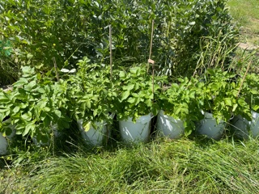

1. **How will my child be included in activities outside the classroom, including school trips?**

We strive to include all children in activities that are taking place outside the classroom. We meet with parents of children who have SEN if individual plans and risk assessments need to be made in order for the child to access the trip.

Work will be done to prepare children for the trip such as using a visual timetable or photos from previous visits. We have found that these preparations are especially key for our children with social communication difficulties and autism.

1. **How accessible is St Wilfrid’s?**

The school building is accessible by wheelchair as internally we have no stairs; due to the age of the premises the access to the field is by way of a fairly steep slope.

There are hand rails at child height on external steps.

All steps are edged with high visibility surfaces.

The school has disabled toilets for both children and adults. We also have the appropriate equipment for nappy changing for children who are independently mobile.

When a child has additional hearing and sight needs we work closely with the Sensory Support Team to ensure that the correct equipment is in place and that staff are trained to use this effectively.

We follow the advice of professionals such as occupational therapists, in striving to adapt our buildings to meet the needs of children with SEND.

1. **How will the school prepare and support my child to join the school and later transfer to a new school for the next stage of education and life?**

Reception class teachers and the SENCo (if appropriate) will visit many children at their pre-school setting in order to meet the children and discuss with staff how the children’s needs can be met at school. We also like to meet with parents of children with SEN before your child starts school if we or you feel that additional arrangements need to be made in order for your child to make a smooth transition to school.

Where appropriate, children with SEN will follow a transition programme when changing year group. This will be adapted to the needs of individuals. We arrange many opportunities for children with SEN to meet with their new teacher in formal and casual ways. Sometimes this is one to one and sometimes this is in a small group. Towards the end of each academic year the views of parents with children with SEN are also sought to provide a holistic approach to their transition needs.

We communicate closely with staff from our local secondary schools and discuss the needs of children with SEN. All children in Year 6 make a visit to their secondary school and additional visits can be arranged if it is felt that this would be helpful. In previous years we have arranged to walk with the children to their new secondary school so they can have extra tours, experience lunchtime and change of lesson times and to meet key members of staff.

For children transitioning to secondary school who are on our SEN Register or may have additional aspects to their needs, we have created a transition form for parents to complete. We acknowledge that parents and carers have a unique view on their child and that transition can be a worrying time for all parties. This form provides the opportunity for school and home to present the needs of the individual and for secondary school to be in full receipt of all the relevant information.

For children with an EHCP, we will always seek their view on their provision and as the child gets older, we invite them to attend Annual Reviews in person and we support them with this.

With some children we create a PATH in conjunction with anybody who is important to that child to help them plan for their future. We use large rolls of paper and we have always found these creation sessions to be uplifting and positive.

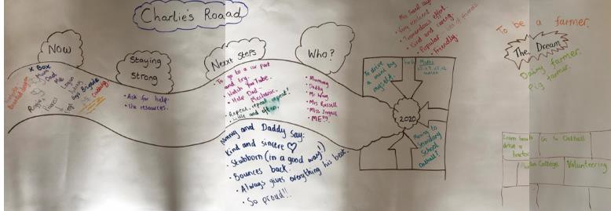

1. **How are the school’s resources allocated and matched to children’s special educational needs?**

The Headteacher, Deputy Headteacher and SENCo meet termly to discuss the needs of children with SEN, plus many other discussions. The SENCo also meets with class teachers and resources are allocated accordingly. Parents of children with an Educational and Health Care Plan (EHCP) are also able to apply for a personal budget.

1. **How is the decision made about what type and how much support my child will receive?**

Children’s needs and support are discussed with parents at parent consultation evenings. If a child needs further support then extra meetings will always be arranged.

The Headteacher, Deputy Headteacher and SENCo meet termly to discuss the needs of children with SEN. The SENCo also meets with class teachers and additional support and resources are allocated accordingly. This is reviewed termly to judge whether the support is having an impact or whether new interventions need to be tried. It is also important to build in time for consolidation of learning from an intervention so breaks are also part of this process. The half termly IDPs are pivotal in this review process.

We track all of our interventions to ensure that they are providing a good level of impact for our children. If an intervention is not providing adequate returns after a suitable time period, we change it.

1. **What are the arrangements for evaluating the effectiveness of the provision made for children and young people with SEND?**

Our school’s Assessment Policy outlines the range of assessments regularly used throughout the school such as:

* Evaluation of the IDP targets. (Including entrance and exit data)

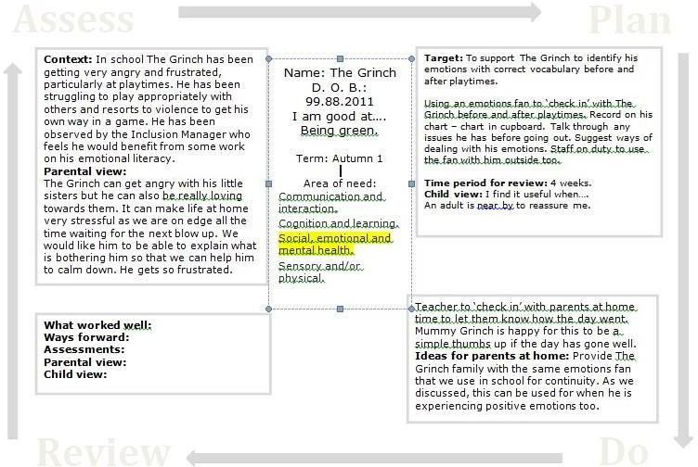

* Tracking of pupil progress, generally as part of whole school tracking system. We use a system called Target Tracker for the whole school population.
* For children on the SEN register who are not working at their Age Related Expectation, we also use a online tracking scheme called Connecting Steps. This is a tracker that allows staff to note the smaller steps of progress and to target what they need to work on next. These targets are also included in their IDPs and in their interventions.
* Any intervention is recorded and overseen by class teachers and the SENCo.
* Progress of children with speech and language needs is assessed and reviewed regularly throughout the year by the Speech and Language Therapy services.
* An Annual Review is held for children with EHCPs; interim reviews can also be arranged throughout the year if deemed necessary.
* Telephone consultation meetings with the Educational Psychology Service, based on the assess-plan-do-review model, can take place throughout the year where a need is identified, although these are limited.
* When children are assessed by the SENCo or by external agencies, meetings and telephone conversations take place with the parents or carers and the class teacher to discuss the findings and how best to address need and meet targets. If an outside agency is visiting one of our pupils, we endeavour to inform parents and carers in advance. This information from outside agencies is then added to future IDPs to ensure that they are tracked.
* When assessing children with SEN, consideration is given to recording needs e.g. a reader, scribe, additional time or rest breaks may be necessary – generally whatever support is provided in the classroom throughout the school year, is provided as far as is permitted during tests.
* Initial concerns about a child’s progress are discussed with the SENCo and parents and followed by referrals to external agencies or placement on intervention programmes as deemed appropriate.

1. **How do we consult pupils with SEN and involve them in their education?**

Children with SEN are encouraged to represent on our School Council and other consultation groups.

Where necessary they will be supported with writing speeches and be given support and/or additional time to practise.

We aim to include children in their target setting collaboratively from verbal feedback directed by teachers.

The targets that are created for the IDPs are also shared with the child by class teachers or teaching assistants.

We encourage and support children with EHCPs to take an active part in their annual review meetings through preparation and making the information and meeting itself accessible and child friendly. In Upper KS2, children will be invited to attend part of the Annual Review to give their views in person.

1. **What are the arrangements relating to the treatment of complaints from parents of children with SEN concerning the provision made at school?**

It is in everyone’s interests for complaints to be resolved as quickly as possible and our SEN complaint procedure is set out in the complaints procedures found on the school website.

1. **How are parents involved in the school? How can I be involved?**

There are two parent Governors elected to the Governing Body.

We have an active Friends of St Wilfrid’s committee (FOSW) who support the school by running events to raise money for additional resources and they have a page on Facebook.

We have an amazing team of parents, grandparents, carers and community volunteers who, when possible, volunteer in to school to help different classes with their learning or assist with a school club. We are very grateful for their support and input. If you would like to get involved, please speak to the school office.

Information on day to day school life is included in a frequent Newsletter and these will also be on our website.

Each year group will send home a weekly email describing the learning from that week.

Our school website reflects general information about each year group. Home-School books are used to communicate with parents on a daily basis or as needed and each year group team has an email address for communication with parents and carers. We also use the app Ping for general communication with parents.

1. **Who can I contact for further information?**

If you would like to discuss something about your child, your first point of contact is your child’s class teacher.

Mrs Russell, our SENCO, has responsibility for children with SEN.

Mrs Russell can be contacted through the school office on 01444 413707.

If you are considering whether your child should join the school, please make an appointment to speak to our Head Teacher, Mr Hateley.

The SEN Governor is Jon Arnold who can be contacted via the school office or the Clerk to Governors. Email: [governors@stwilfrids-hh.school](mailto:governors@stwilfrids-hh.school)

The Parent Partnership Service can also give advice.

<https://www.westsussexcarers.org.uk/Link/link_parent_partnership.htm>

Helpline: 0845 075 1008 - Monday to Friday during office hours.

Email: [parent.partnership@westsussex.gov.uk](mailto:parent.partnership@westsussex.gov.uk)

The Local Offer website for West Sussex: [www.westsussex.local-offer.org](http://www.westsussex.local-offer.org/)

For further avenues of information and support, please look on our school website.