**Tuesday 12th November 2024**

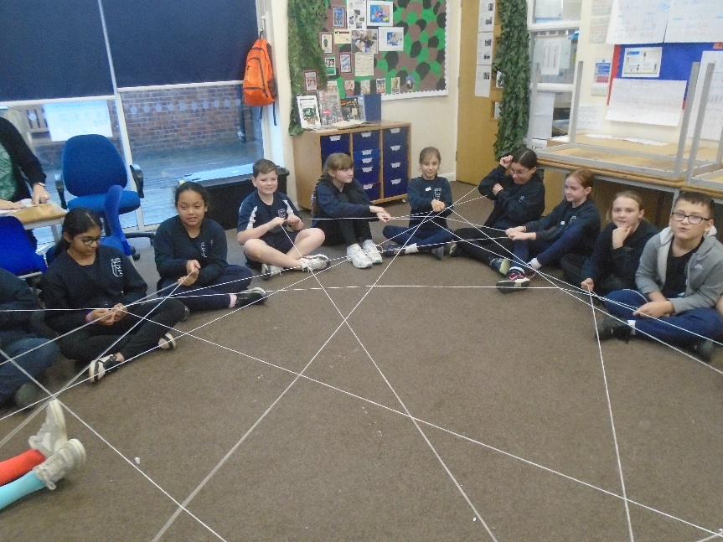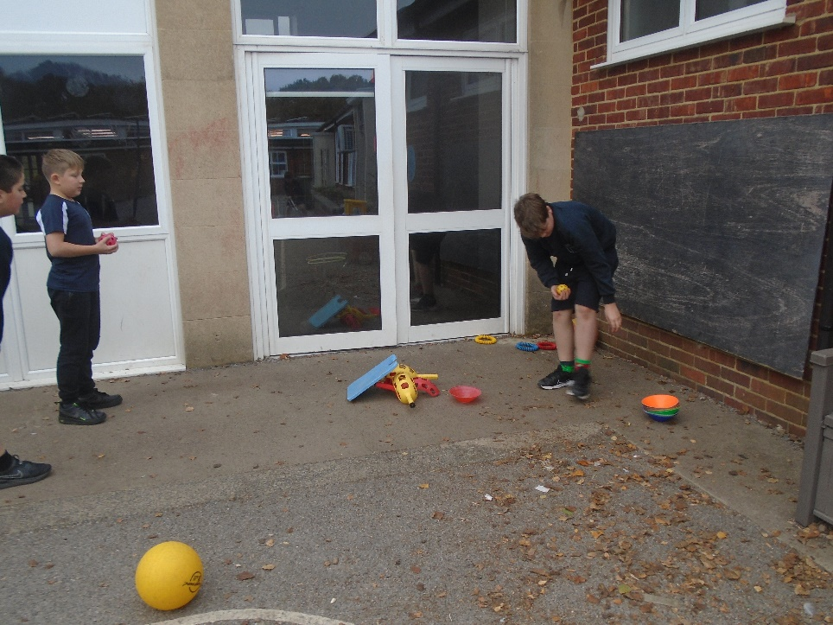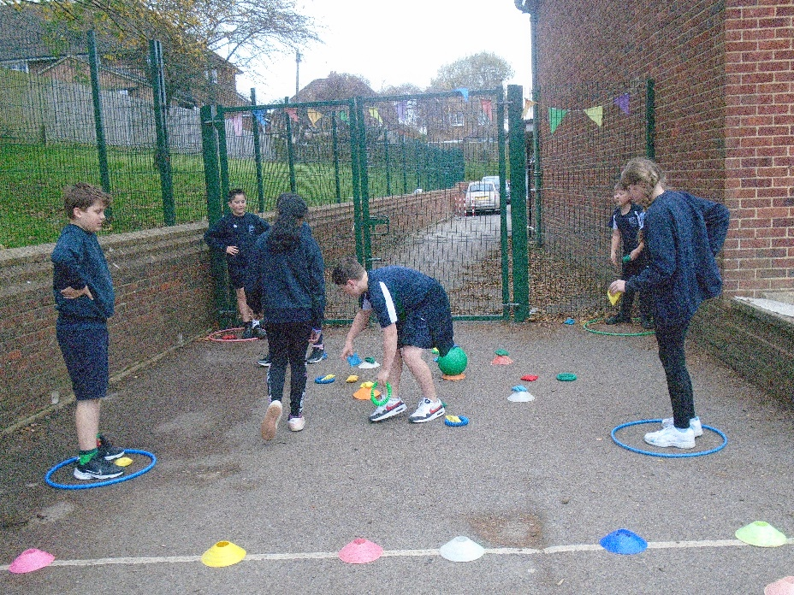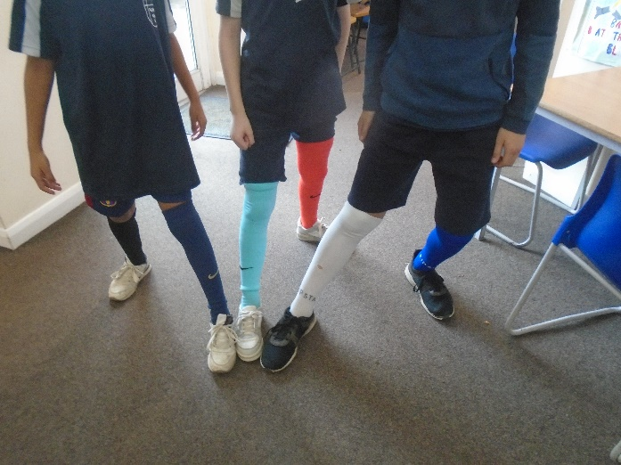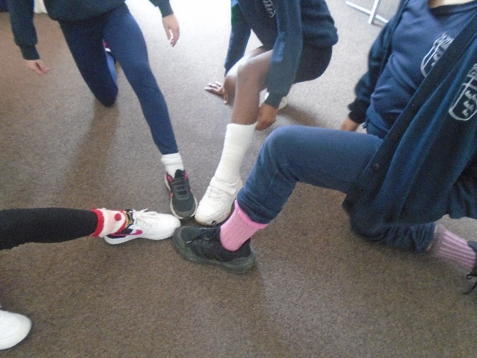**IALT: Explore the value of Respect and learn about anti-bullying week.**

In Year 6 we explored anti-bullying week with a series of activities.

We wore odd socks to school, in order to celebrate differences between us.

We coloured in odd socks to be displayed around the school.

We created our own team games in PE and taught these to each other in a respectful way.

We made a “Respect Web” by saying respectful things to each other.

We have learned that it is ok to disagree but we can disagree respectfully!